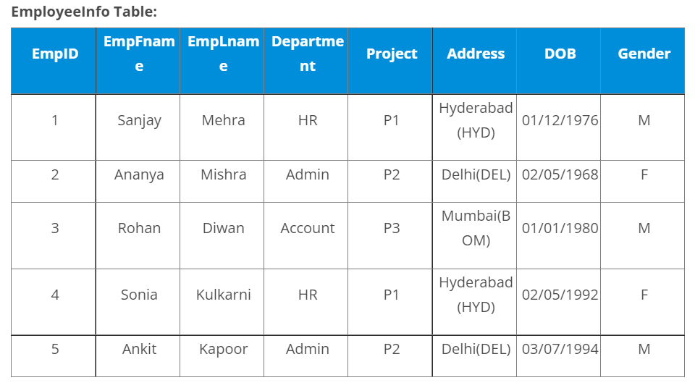

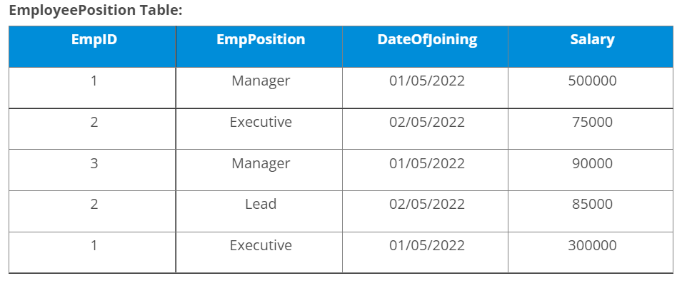

1. **Write a query to find the Nth highest salary from the table without using TOP/limit keyword.**

SELECT DISTINCT Salary FROM EmployeePosition E1

WHERE N-1 = (SELECT COUNT (DISTINCT Salary) FROM EmployeePosition E2

WHERE E2.Salary > E1.Salary) ;

Select distinct salary from EmployeePosition E1

Where 3= ( select COUNT( DISTINCT( SALARY ) ) FROM EmployeePostion E2 )

Where E2.salary>E1.salalry;

======== or by using limit find Nth heighest===========

select salary from EmployeePosition order by salary desc limit N-1,1;

1. **Write a query to fetch only the place name(string before brackets) from the Address column of EmployeeInfo table.**

Select substr( address,1, **LOCATE (** ‘(’,address ) ) from Employeeinfo;

1. **Write a query to fetch 50% records from the EmployeeInfo table.**

Select * from employeeinfo where empid <= ( select count(empid)/2 from employeeinfo );

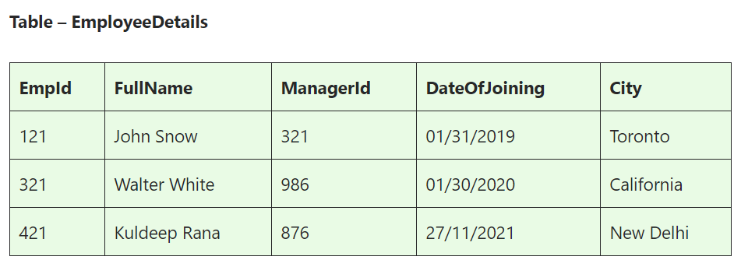

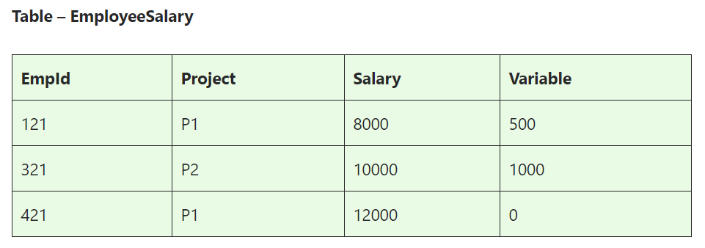

1. **How to fetch duplicate records from a table**

Select empfname, emplname, count(department) as num from employeeinfo group by empfname, emplname having num>1;

1. **Write an SQL query to fetch common records between two tables.**

SELECT *

FROM EmployeeSalary

WHERE EmpId IN

(SELECT EmpId from Manager Salary);

1. **Write an SQL query to remove duplicates from a table**

DELETE E1 FROM EmployeeDetails E1

INNER JOIN EmployeeDetails E2

WHERE E1.EmpId > E2.EmpId

AND E1.FullName = E2.FullName

AND E1.ManagerId = E2.ManagerId

AND E1.DateOfJoining = E2.DateOfJoining

AND E1.City = E2.City;

1. **Write an SQL query to create an empty table with the same structure as some other table.**

Create table new_table select * from employeesalary where 1=0;

Or

Create table new_table as table employeeSalary limit 1;

8)